This guide has been created with the support of children, young people and their families

We’re supporting ‘This is how… #WeveGotThis’ and encouraging people to
share their individual advice, tips and thoughts around wellbeing. Keep updated with ideas to improve your mood by following Instagram: @thisishow_Norfolk
TikTok: @thisishow_Norfolk Hashtag: This is how#WeveGotThis

Get involved
If you are a young person, parent or carer and would like to find out more about how to get involved in helping to design mental health services, then please contact
Jo Hand, Senior Participation Youth Worker at MAP: Email: johand@map.uk.net orcall/text 07384 214590

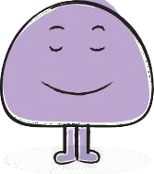

Support and self helpguide
forchildren, young people and families

3

Support available now
you don’t need a referral, you can get in touch straight away
- Just One Norfolk - Advice and support for children,
youngpeople and their families/carers in Norfolk and Waveney Visit: www.justonenorfolk.nhs.uk/emotional-health
or call: Just One Number on 0300 300 0123 if you live in Norfolk or 03456 078866 if you live in Waveney
- The Source - Information and advice for young people in Suffolk Visit: www.thesource.me.uk/
- Kooth - FREE Online counselling and peer support for 11-25 year olds. Visit: www.kooth.com
- ChatHealth - A secure text messaging service for parents, carers, and young people to confidentially ask for help about a range of issues and find out how to access local services.

Norfolk: Text: 07480 635060
Suffolk: Text: 07507 333356
- MAP - FREE confidential support, information and advice on issues such as housing, money and mental health for people aged 11-25. Visit: www.map.uk.net or call the MAP helpline: 0800 0744454

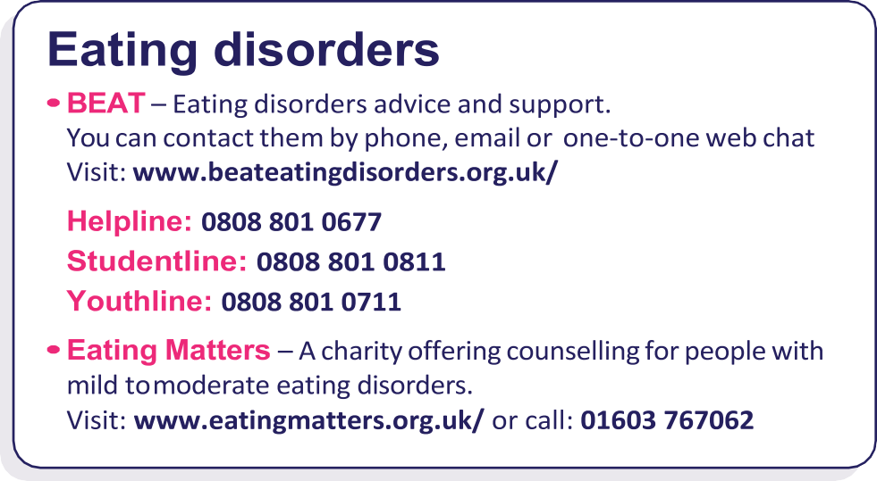

Self-harm
Advice and support for those who self-harm:
  - Harmless: email info@harmless.org.uk or visitwww.harmless.org.uk

Self-injury support (for women and girls):
call 0808 800 8088 or visit www.selfinjurysupport.org.uk

CALM (for men): call 0800 58 58 58 or
visit www.thecalmzone.net/issues/self-harm/
  - National Self Harm Network forums: visit www.nshn.co.uk
  - Mind: call 0300 123 3393 or visit www.mind.org.uk

YoungMinds Parents Helpline: call 0808 8025544

LGBT+ support service
- Norfolk LGBT+ Project - If you live in Norfolk and Waveney, are lesbian, gay, bisexual or transgender or in doubt of your sexuality or gender identity, you can get advice, peer-support and information here: www.norfolklgbtproject.org.uk/ or call: 01603 219299

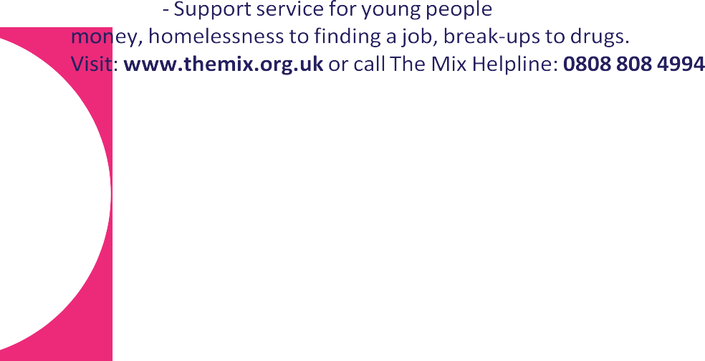03
o

Bereavement support

Nelson’s Journey
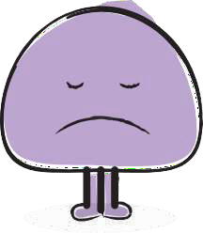
If you are under 18 and live in Norfolk and have experienced the death of someone close to you, you can get support here.
Visit: www.nelsonsjourney.org.uk or call: 01603 431788

Suffolk Cruse
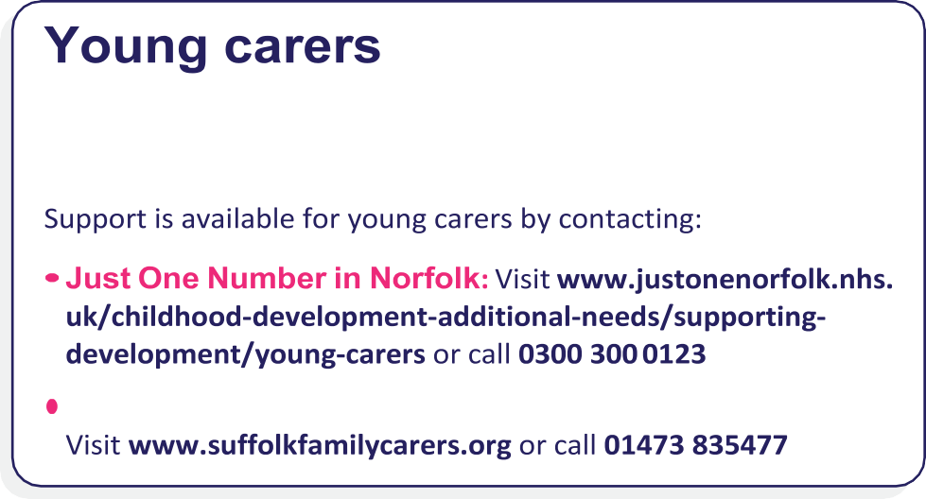If you are under 18, live in Suffolk and have experienced the death of someone close to you, you can get support here. Visit: www.cruse.org.uk/get- help/local-services/eastern-england/suffolk or call 01473 230888
A young carer is a child or young person who helps to look after a
relative. This may be due to them having an illness, a disability, mental health concern or a drug or alcohol problem.
Suffolk Family Carers in Suffolk:

Children and young people with additional needs
Special educational needs and disabilities (SEND), can affect a child or young person’s ability to learn. It can also affect their behaviour or ability to socialise, reading and writing, ability to understand things,
concentration levels, or physical ability. If you think your child may have special educational needs you can contact:

Norfolk SEND Partnership Information, Advice and Support Service: Visit www.norfolksendpartnershipiass.org.uk or call 01603 704070
- SENDIASS in Suffolk:
Visit www.suffolksendiass.co.uk or call 01473 265210
For information and advice in relation to behaviour and sleep for children with additional needs. Visit www.justonenorfolk.nhs.uk/ childhood-development-additional-needs/behaviour-sleep

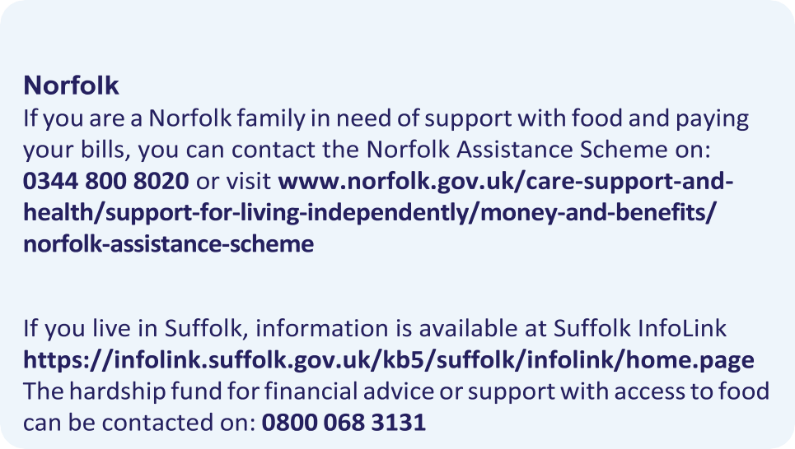
Family support
Suffolk

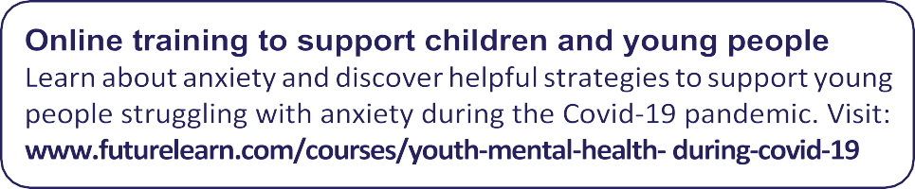

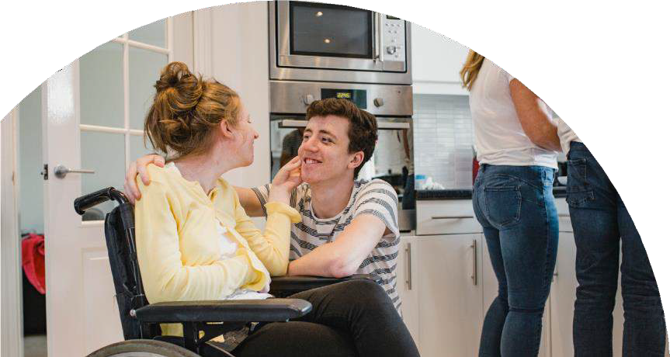05

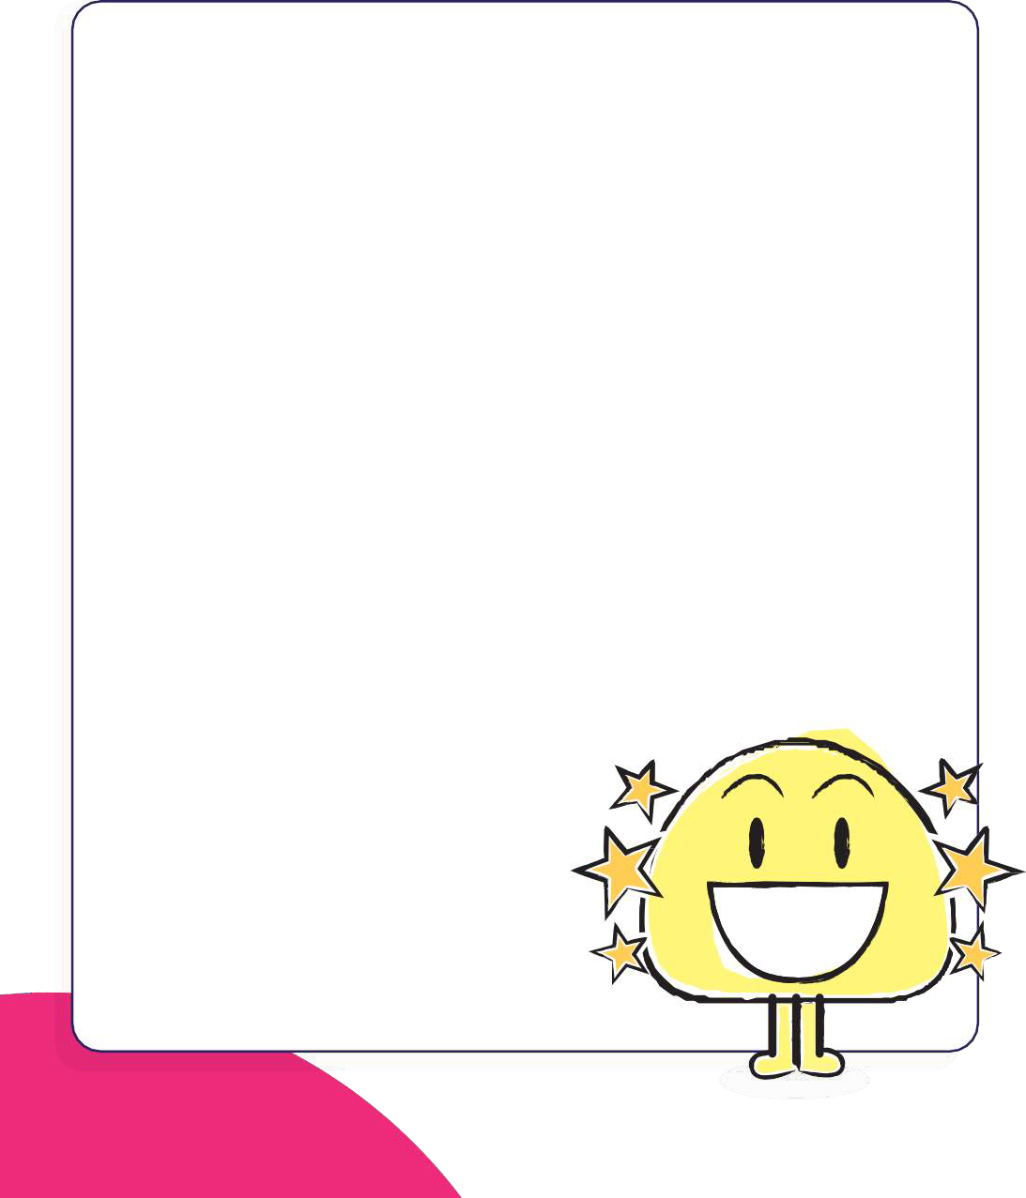Five ways to wellbeing
Many factors can influence our wellbeing but research says that doing one or more of these five different things regularly can help boost your mood and make you feelhappier.

Be active
1
Go for a walk or run. Step outside. Cycle. Play a game.
Do some gardening. Dance. Exercising makes you feel good. Pick something you enjoy and try to do it regularly.

Help someone
2
Do something nice for a friend or someone you know or give thanks. Smile. Volunteer your time. Join a community group.

Connect with the people around you
3
With family, friends, colleagues and neighbours. At home, work, school or in your local community.

Try something new and keep learning
4
Learn to play an instrument or how to cook your favourite food. Set a challenge you will enjoy. It’ll help boost your confidence and can be fun.

Take notice
5
Be aware of the world around you and what you are feeling. Catch sight of the beautiful.
Notice the changing seasons. Savour the moment, whether you are walking to school, eating lunch or talking
to friends.

Self help techniques

Managing anxiety and emotions

7/11 breathing technique
Inhale deeply for seven counts and exhale slowly for eleven counts. This technique aims to slow down the heart rate and prevent panic from escalating. We would encourage practising the 7/11 breathing technique for at least 5-10 minutes, or until the feelings of panic and worry decrease.

5, 4, 3, 2, 1 grounding technique
Aims to reduce feelings of being overwhelmed and to encourage relaxation:
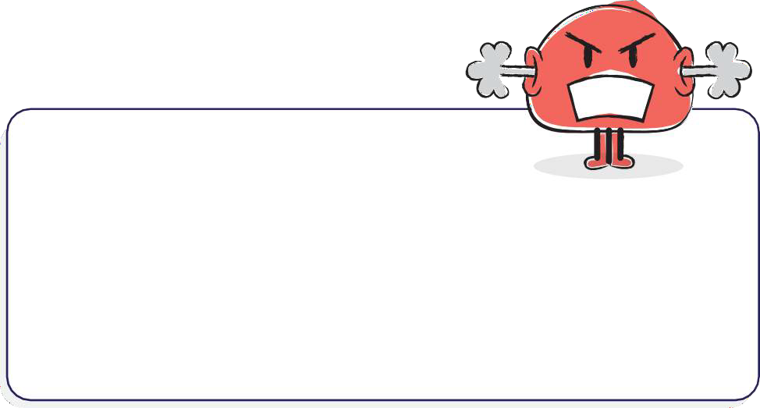

Note 1 thing - you can taste

It’s okay to feel angry but there
are ways to manage anger:

Further information on coping with anger can be found at: www.mind.org.uk/ information-support/types-of-mental-health-problems/anger/about-anger

06 07
06

There are a number of other suggested self-care things we can do to look after our own mental health – here are some of them:
Self soothe box

You could access a self soothe box when you are experiencing symptoms of anxiety. The self soothe box would contain items which should help you feel more relaxed andcomfortable.

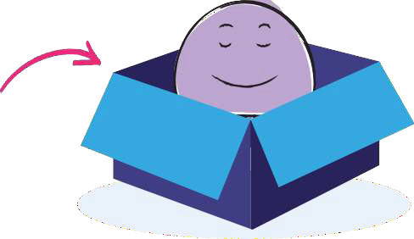
A self soothe box could be in an easy to reach location, such as a bedroom or in the living room. If possible, you could use this box in a quiet environment which you consider to be safe.

These are items that could be included in your self soothe box:

Eat a healthy diet
and avoid certain foods Swapping processed food for healthier alternatives.

Try some
relaxation techniques
Having a few minutes in your day just to be aware of your breathing and become fully relaxed can calm the mindcompletely.

Develop friendships that are important
Being with people who make you

Take time away from technology
See how it feels to take yourself away from your phone for a bit, it doesn’t have to be for long but it can make a lot of difference.

Dance
Put on your favourite songs and have a little boogie in the living room. Even small movements can make a big difference.

Be kind to yourself
Self kindness won’t necessarily
stop your thoughts or feelings

Touch - Items which are interesting to touch, which serve as a good distraction for hands. This may include fidget cubes/ spinners, playdough or stress balls. This may encourage muscles to relax, which can help to reduce feelings of anxiety.

Smell - Smells which can help promote positive feelings and relaxation. This may include peppermint or lavender.
Music - This may be a favourite music playlist or music aimed at promoting relaxation. This could be a wind-up music box or played
feel confident and good about yourself can really boost your mental health.
Write three positive things that you did each day Writing things down can help to arrange thoughts.
from being difficult, but it might provide some small comfort in the midst of them.
Talk to a friend about how you are coping Ringing for a chat could help you get away from how you’re feeling.

Memories - These could be items which have positive memories attached to them. This could include photos, toys or novelty
through a music device.
Water - Regular sipping of water is a good way to keep a steady rhythm to breathing and heart
- Talk to your friends online or find a safe online support group.
- Take part in a photography challenge with your family or friends.
- Create a playlist with your friends.

items. This may help to boost positive emotions and reduce feelings of worry or frustration.

rate, helping to reduce feelings of worry.
Organise your day Writing a list and organising yourself may help to prevent stress.

Try to get showered and dressed each morning
Set some goals for the future
Goal-setting can give you some extra motivation and
encouragement. It may also help with your daily routine, giving you something to work towards to get you through the day.

Further information can be found at: www.annafreud.org/on-my-mind/self-care/
09

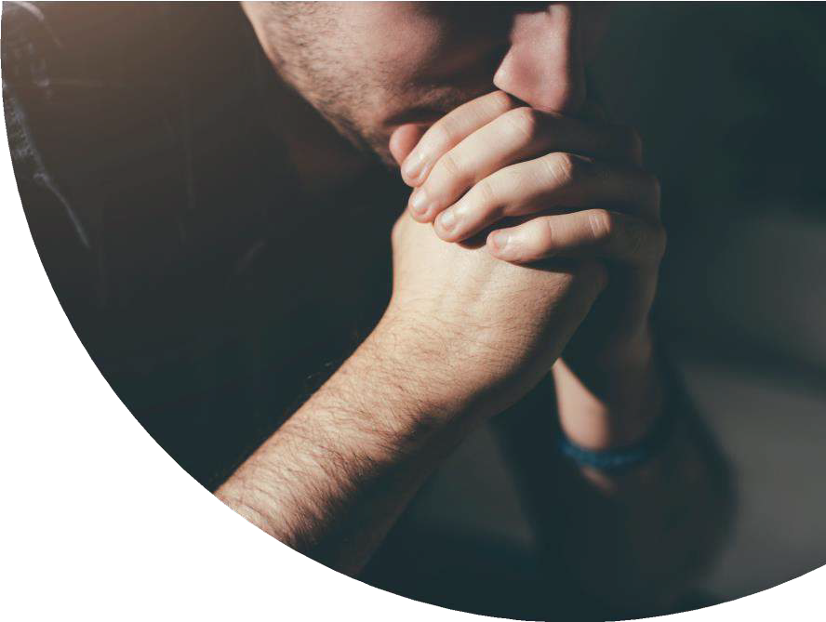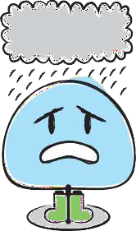Apps

If you need help for a mental health crisis or emergency, you
should get immediate expert advice and assessment.
There are lots of free apps available which have been assessed by the NHS. You could try some of them to see which ones work best for you. Here are just a few of them:

BlueIce: This app helps young people manage their emotions and reduce urges toself-harm.
Calm Harm: Reduce urges to self-harm and manage emotions in a more positive way.
Catch It: Learn to manage negative thoughts and look at problems differently.
distrACT: Quick and discreet access to information and advice about self-harm and suicidal thoughts.

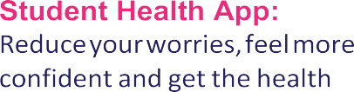24/7 First Response Service – call: 0808196 3494
MeeTwo: A safe and secure forum for teenagers wanting to discuss any issue affecting their lives.
information you need as a student.
Thrive: Use games to track your mood and teach yourself methods to take control of stress and anxiety.

Visit:www.nhs.uk/apps-library/category/mental-health/ for details of other available apps.

Staying safe online
Thinkuknow is an education programme which protects children both online and offline. For further information visit: www.justonenorfolk.nhs.uk/staying-safe/staying-safe-online
10
- 999 - If someone’s life is at risk

- Childline - If you’reunder 19, youcantalk to Childlineaboutany concernyou have, call 0800 1111. The numberwill not appear on your phonebill

- Papyrus - If you are (or know a young person) thinking of suicide,
Papyrus offers confidentialsuicideprevention advice call: 0800 068 4141

- Samaritans - If you just need to talk, any time of the day or night, these services offer confidential advice from trained volunteers. Call: 116 123 to talk to Samaritans, or email: jo@samaritans.org for a reply within 24hours

- Text: SHOUT to 85258 to contactthe Shout CrisisText Line, or TextYM if you’reunder 19

